LAB ASSIGNMENT 4

U24CS076 RUSHANG BAGADA

Q1: Design the following web pages using HTML and CSS.

● Use following tags

a. Anchor tag (href, target)

b. Unordered List

c. div

● Use the following CSS attributes

a. Margin

b. Padding

c. Position

d. Float

e. Left

f. Right

g. Background-image

h. Display

i. List Style

j. Background-color

k. Border

l. Element : Hover (for mouse hover effect)

m. Border-radius

n. max-width

HTML:

<!DOCTYPE *html*>

<html *lang*="en">

<head>

    <meta *charset*="UTF-8">

    <meta *name*="viewport" *content*="width=device-width, initial-scale=1.0">

    <title>Document</title>

    <link *id*="style" *rel*="stylesheet" *href*="1.css">

</head>

<body>

    <div *class*="div1">

        <h1>Welcome to My Homepage</h1>

        <h4>Use menu to select different stylesheets</h4>

    </div>

    <div *class*="div2">

        <div *class*="div21">

            <ul *class*="ul1">

                <li><button *onclick*="*b1*(1)">Stylesheet 1</button></li>

                <li><button *onclick*="*b1*(2)">Stylesheet 2</button></li>

                <li><button *onclick*="*b1*(3)">Stylesheet 3</button></li>

                <li><button *onclick*="*b1*(4)">Stylesheet 4</button></li>

                <li><button *onclick*="*b1*(0)">no Stylesheet</button></li>

            </ul>

        </div>

        <div *class*="div22">

            <h2>

                Samepage different styles

            </h2>

            <p>Lorem ipsum dolor sit amet consectetur adipisicing elit. Aperiam, illum? Delectus, qui maxime error,

                nulla

                reiciendis aspernatur dolorem porro molestiae laudantium doloribus nostrum autem iusto vitae nobis

                accusamus, ex voluptatum?Lorem ipsum dolor, sit amet consectetur adipisicing elit. Numquam laborum sequi

                tempora pariatur, nihil, harum eaque soluta nulla unde beatae inventore reiciendis hic quos quasi esse,

                quas eveniet quibusdam nostrum ratione perspiciatis. Ex delectus accusamus asperiores nulla sequi,

                repellat aspernatur sunt consequatur pariatur, consequuntur deserunt illo saepe at debitis culpa

            </p>

            <a *ondblclick*="*b1*(1)" *href*="">Stylesheet 1-</a> <a *ondblclick*="*b1*(2)" *href*="">Stylesheet 2-</a> <a *ondblclick*="*b1*(3)" *href*="">Stylesheet 3-</a> <a *ondblclick*="*b1*(4);" *href*="">Stylesheet 4</a>

            <h2>No stylesheet</h2>

            <p>Lorem, ipsum dolor sit amet consectetur adipisicing elit. Et tempore porro itaque beatae quas inventore?

                Lorem ipsum dolor sit amet consectetur adipisicing elit. Repudiandae inventore id praesentium quos neque

                explicabo.</p><a *href*="" *ondblclick*="*b1*(0)">no Stylesheet</a></p>

            <div *class*="div223">

                <h2>Side-Bar</h2>

                <p>Lorem ipsum dolor sit amet consectetur adipisicing elit. Ipsa, esse. Lorem ipsum dolor sit amet

                    consectetur adipisicing elit. Repudiandae inventore id praesentium quos

                    neque

                    explicabo.</p>

            </div>

        </div>

    </div>

    <script>

*function* *b1*(sheet) {

*if* (sheet *==* 0) {

*document*.*getElementById*('style').*removeAttribute*('href');

            } *else* {

*document*.*getElementById*('style').*setAttribute*('href', sheet *+* '.css');

            }

        }

    </script>

</body>

</html>

CSS1:

\*{

    padding: 0*%*;

    margin: 0*%*;

}

h1{

    font-size: 50*px*;

    color: white;

}

h4{

font-size: 20*px*;

color: white;

}

*.div1*{

    background-color: #4fa6e4;

    padding-left: 10*px*;

    border-bottom-right-radius: 10*px*;

    border-bottom-left-radius: 10*px*;

}

*.div2*{

   display: flex;

}

*.div21*{

    width: 20*%*;

    background-color: rgb(255, 255, 255);

    margin-right: 5*px*;

}

*.div22*{

    width: 80*%*;

    background-color: rgb(255, 255, 255);

    margin-left: 5*px*;

 }

button{

    text-align: start;

    background-color:#938d8d;

    width: 100*%*;

    height: 25*px*;

    margin: 5*px*;

    border-radius: 7*px*;

    padding: 5*px*;

    border: none;

    cursor: pointer;

}

p{

    text-align: justify;

    margin-bottom: 20*px*;

}

*.div223*{

    border-radius: 10*px*;

    background-color: rgb(234, 129, 234);

}

a {

    text-decoration: none;

}

li {

    list-style-type: none;

}

OUTPUT:

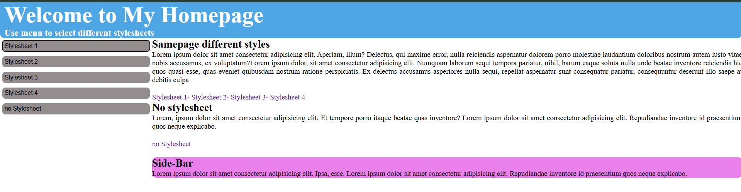

CSS2:

\* {

    padding: 0*%*;

    margin: 0*%*;

}

a {

    text-decoration: none;

}

h1 {

    font-size: 50*px*;

    color: white;

}

h4 {

    font-size: 20*px*;

    color: white;

}

*.div1* {

    background-color: #ff9854;

    padding-left: 10*px*;

    border-bottom-right-radius: 10*px*;

    border-bottom-left-radius: 10*px*;

}

*.div2* {

    display: flex;

}

*.div21* {

    width: 20*%*;

    background-color: rgb(255, 255, 255);

    margin-right: 5*px*;

}

*.div22* {

    width: 80*%*;

    background-color: rgb(255, 255, 255);

    margin-left: 5*px*;

}

button {

    text-align: start;

    background-color: #aa988c;

    width: 100*%*;

    height: 25*px*;

    margin-top: 5*px*;

    margin-right: 5*px*;

    border-radius: 7*px*;

    border: none;

    cursor: pointer;

}

button*:hover*{

    background-color: #ff9854;

}

p {

    text-align: justify;

    margin-bottom: 20*px*;

}

*.div223* {

    border-radius: 10*px*;

    background-color: rgb(255, 255, 255);

}

li {

    list-style-type: none;

}

h2 {

    padding: 10*px*;

    padding-left: 0*px*;

    margin-bottom: 10*px*;

}

a{

    text-decoration: none;

}

OUTPUT: 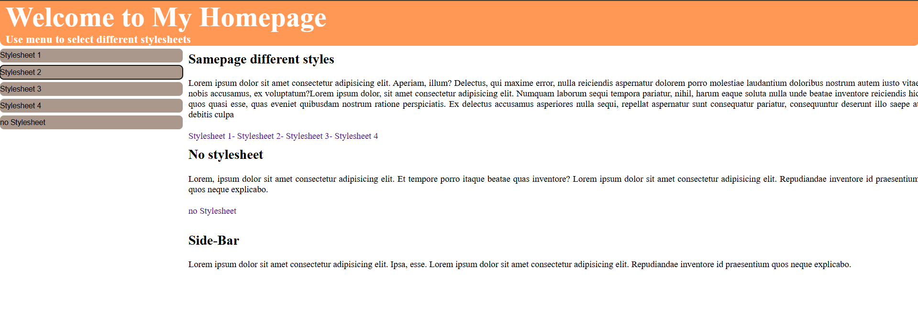

CSS3:

\* {

    padding: 0*%*;

    margin: 0*%*;

}

a {

    text-decoration: none;

}

li{

    list-style-type: none;

}

h1 {

    font-size: 50*px*;

    color: white;

}

h4 {

    font-size: 20*px*;

    color: white;

}

body{

    background-color: #04916e;

}

*.div1* {

    background-color: #04916e;

    padding-left: 10*px*;

    border-bottom-right-radius: 10*px*;

    border-bottom-left-radius: 10*px*;

}

*.div2* {

    display: flex;

    flex-direction: row-reverse;

}

*.div21* {

    width: 20*%*;

    background-color: rgb(255, 255, 255);

    margin-right: 5*px*;

}

*.div22* {

    padding-left: 10*px*;

    width: 80*%*;

    background-color: rgb(255, 255, 255);

    margin-left: 5*px*;

}

button {

    background-color: #aa988c;

    width: 100*%*;

    height: 25*px*;

    margin-top: 5*px*;

    margin-right: 5*px*;

    border-radius: 20*px*;

    border: none;

    cursor: pointer;

}

button*:hover* {

    background-color: #04916e;

}

p {

    text-align: justify;

    margin-bottom: 20*px*;

}

*.div223* {

    border-radius: 10*px*;

    background-color: rgb(255, 255, 255);

}

h2 {

    color: #04916e;

    padding: 10*px*;

    padding-left: 0*px*;

    margin-bottom: 10*px*;

}

OUTPUT: 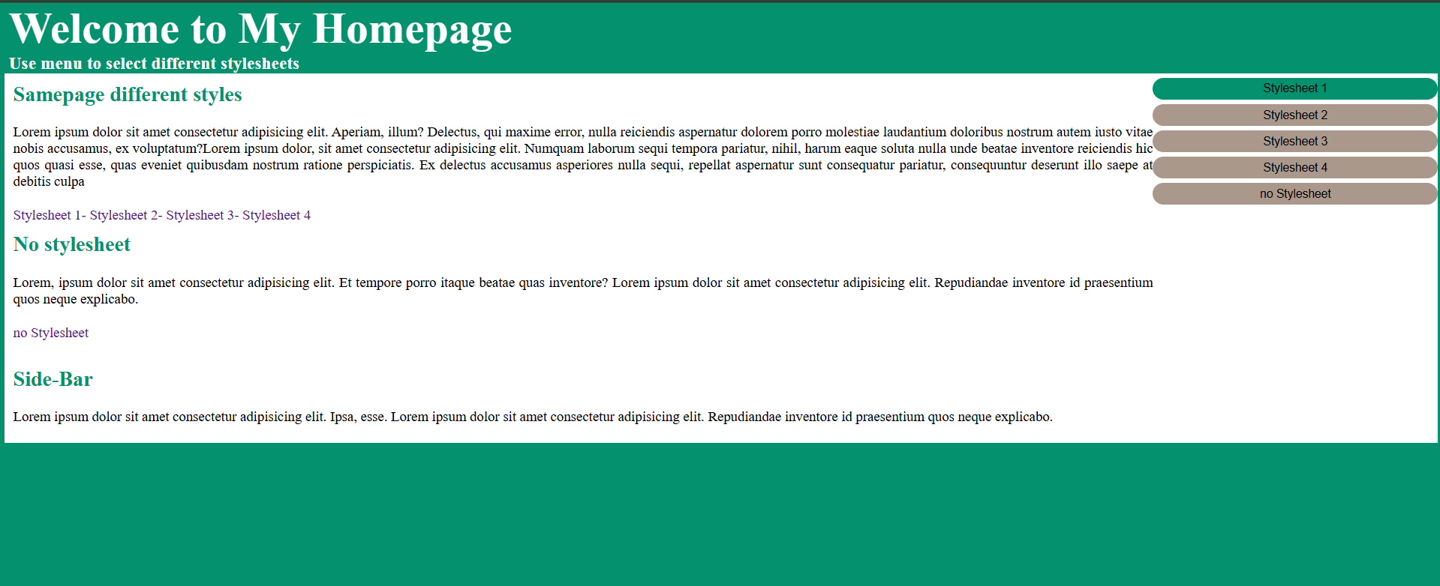

CSS4:

\* {

    padding: 0*%*;

    margin: 0*%*;

}

h1 {

    font-size: 50*px*;

    color: rgba(160, 0, 0, 0.862);

}

h4 {

    font-size: 20*px*;

    margin-bottom: 20*px*;

    color: black;

}

*.div2* {

    display: flex;

    flex-direction: column;

}

ul{

    display: flex;

}

li{

    list-style-type: none;

    margin-right: 10*px*;

    width: 100*%*;

}

button{

    width: 100*%*;

    height: auto;

    border-radius: 5*px*;

    border: none;

    padding: 5*px*;

    background-color: #6e6e6e;

    color: white;

    cursor: pointer;

}

button*:hover*{

    background-color:rgba(160, 0, 0, 0.862);

}

*.div22*

{

 margin-left: 10*px*;

}

p {

    text-align: justify;

    margin-bottom: 20*px*;

}

a {

    text-decoration: none;

}

li {

    list-style-type: none;

}

h2*:hover*{

    color:rgba(160, 0, 0, 0.862);

}

h2{

    margin-top: 10*px*;

    padding: 10*px*;

        padding-left: 0*px*;

        margin-bottom: 10*px*;

}

OUTPUT:

